Assembly language project

TIC TAC TOE

1. Display format:

At start you have to ask the names of two players. And save them in a file if they not saved previously.

Your display should be like:

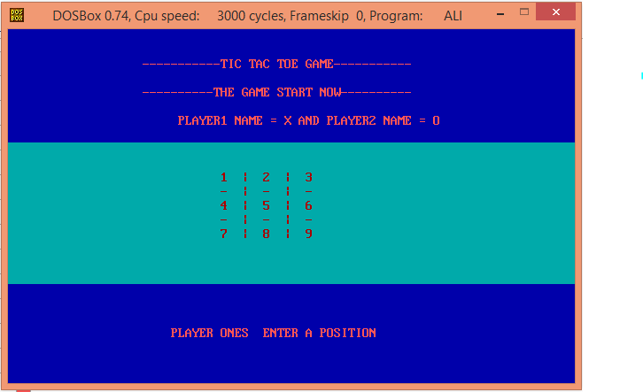

User input validation is compulsory.

1. Functions:

In MAIN PROC you can call only functions or push parameters in stack. All of remaining code should be in separate functions. Each function should be well documented. Parameter passing should be through stack.

1. **Array Processing:**

You have to use Based Indexed addressing mode to access array.

1. File Handling:

You have to main records of players in a file. Player name, number of times he plays game and number of times he wins and loses. You also have to rate the players a player who win maximum times should be rated higher.

* **Any student who will handle mouse events will awarded bonus marks in sessional.**
* **DONOT let any one copy your project. In case of a copy both students will be awarded a ZERO OR may be some negative marks as well.**